About The Accelerated Cure Project for Multiple Sclerosis

Accelerated Cure Project for Multiple Sclerosis is a national nonprofit organization dedicated to curing MS by determining its causes. Focused primarily on accelerating the pace of MS breakthroughs, the Accelerated Cure Project seeks to remove obstacles to investigating the causes of MS, and encourages collaboration between research organizations and clinicians.

Its major success has been the creation of a large-scale, multidisciplinary MS Repository of blood samples and data from people with MS and matched controls. With the help of funds raised by efforts like Music to Cure MS, samples are being collected at sites across the United States. These samples are currently being used by over 63 studies throughout the world.

In April 2012, ACP and the MassGeneral Institute for Neurodegenera-tive Disease (MIND) launched the Multiple Sclerosis Discovery Forum (MSDF)—an information portal and interactive virtual community that educates and connects investigators who study MS and other demyelinating disorders of the central nervous system.

Multiple Sclerosis, or MS, is a chronic demyelinating disorder of the central nervous system affecting over 400,000 people in the US and 2 million worldwide. MS commonly results in severe disability: debilitating fatigue, loss of bladder and bowel control, the inability to walk, impaired vision or blindness, cognitive dysfunction, and other unpredictable impairments. No one knows what causes Multiple Sclerosis, there is no known cure, and treatments are modest at best.

For more information about the Accelerated Cure Project or to make a corporate or individual contribution, call 781/487-0008, or visit www.accelerated cure.org.

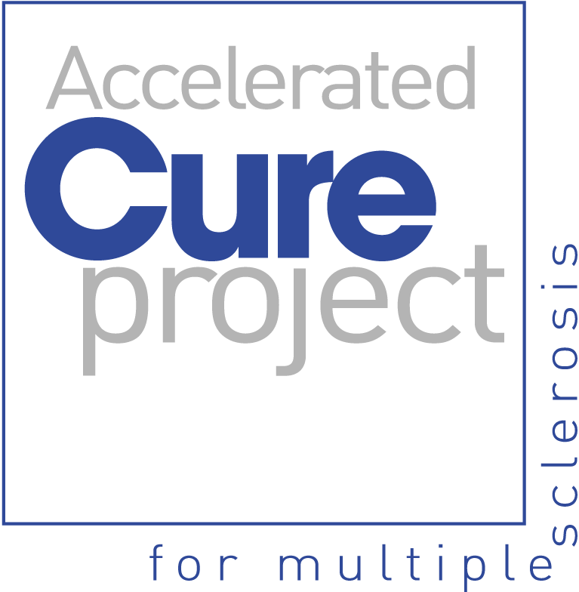

The 11th Annual Accelerated Cure Project
Benefit Concert

A concert of classical vocal music
to benefit the
Accelerated Cure Project
for Multiple Sclerosis

Park Avenue Congregational Church
50 Paul Revere Road
Arlington, MA

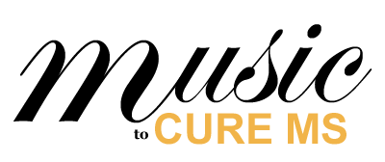

Sunday, October 27, 2013, 3 - 5 PM


a major supporter of Music to Cure MS

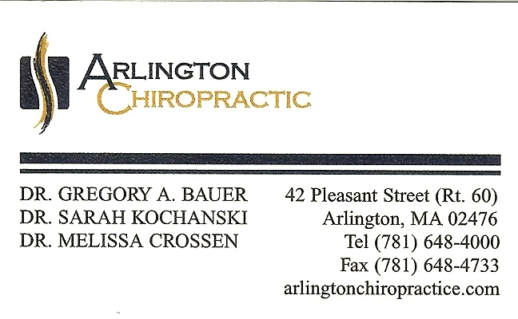

a major supporter of Music to Cure MS

Acknowledgements
We would like to thank

Karen Amlaw  Arlington Swifty Printing  Liz Blumenthal  Rebecca Burstein  Andy Buscemi  Marion Leeds Carroll  Susan and Hong Chin, PACC  James Eggleston | Art Mellor, founder of Accelerated Cure Project  Lyman Opie  Lynn Shane, Boston Singers Resource  Lindsey Miller, ACP  Play Time  Robinson Music
and the many others who have joined to
make this concert a success.

Note: this year we're includng a silent auction in addition to
our usual raffle - see separate sheet.
Raffle ticket prices:

$2 = 1 ticket | $5 = 3 tickets
$10 = 7 tickets | $25 = 30 tickets

We would like to thank the generous donors of
prizes for today’s raffle and silent auction:

Arlington Restaurant & Diner  Arts & Craftsman  Artwear  Ava Vatsky  Balich 5 & 10  Big Picture Custom Framing  Brighams Ice Cream  Continentale Hair Salon  Francesca's Kitchen  Infinity Beauty Salon  Lakota Bakery  Longwood Opera  The Madrona Tree  M.Y. Salon and Day Spa | New Dimensions in Hair  Not Your Average Joe's  La Posada Restaurante  QuadCycles  Stop&Shop  The Center for Arts in Natick - TCAN  Theatre@First  Tony's Barber Shop  Trader Joe's  Vincent's Barber Shop  Villa House of Pizza  Wellesely Symphony Orchestra  Worcester Chamber Music Soc.

 1427 Massachusetts Ave, Arlington, MA



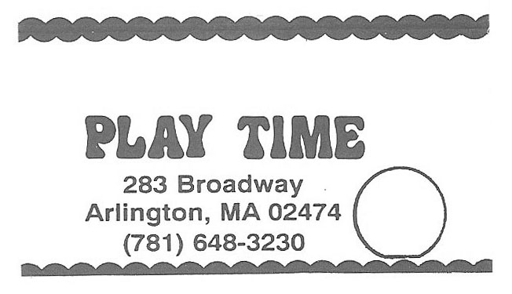



Program

Una voce poco fa, Il Barbiere di Siviglia -Giocchino Rossini
Sophie Michaux, Mark McNeill

Je dis que rien ne m'épouvante, Carmen - Georges Bizet
Laura Hansen, Mark McNeill

Io son l'umile ancella, Adriana Lecouvreur - Francesco Cilea
Karen Amlaw, Mark McNeill

O zittre nicht, Die Zauberflote - Wolfgang Amadeus Mozart
Alyssa Kugler, Mark McNeil

Come dal ciel precipita, Macbeth - Giuseppe Verdi
Miles Rind, Mark McNeill

Habanera, Carmen - Georges Bizet
Janine Wanée, Mark McNeill

Liebhaber in allen Gestalten - Franz Schubert
Marion Leeds Carroll, James Hay

Song to the moon, Rusalka - Antonín Dvořák
Sangeetha Vandeyar Appavoo, Mark McNeill

Intermission

Schlummert Ein, BWV 82 (Ich habe genug) - Johann Sebastian Bach
Elizabeth Anker, Seele Musicale (Jagan-Nath Khalsa and friends)
Suicidio, La Gioconda - Amilcare Ponchielli
Karen Amlaw, Mark McNeill
Dove Sono, Le Nozze di Figaro - Wolfgang Amadeus Mozart
Kimberly States, Mark McNeill

-- continued

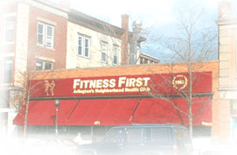
Fitness First of Arlington
471 Massachusetts Ave
Supports Music to Cure MS





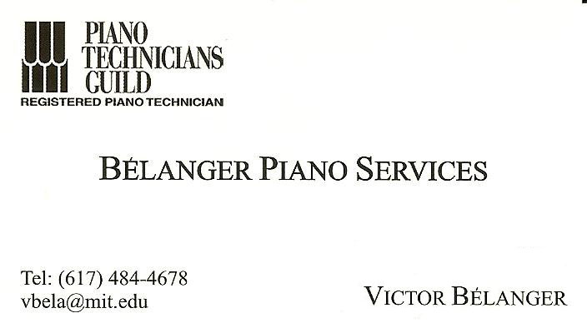

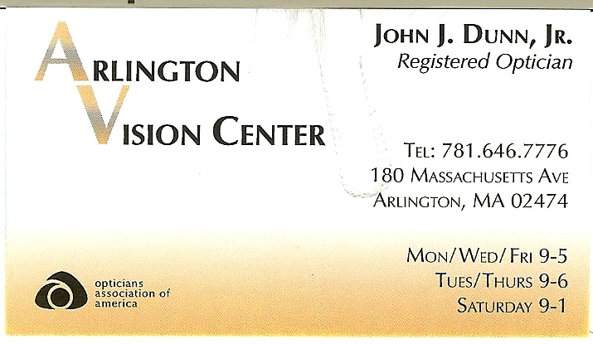

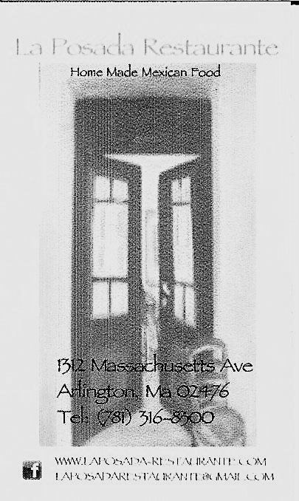

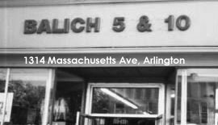

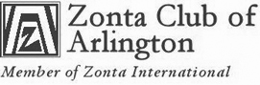

- Das verlassene Mägdlein, Mörike-Lieder - Hugo Wolf
- Meine Liebe ist grün wie der Fliederbusch, Junge Lieder I - Johannes Brahms
Sonya Taaffe, Mark McNeill

Riddle Trio, The Scarlet Pimpernel - Frank Wildhorn/Nan Knighton
Tom Frates, Kate Meifert, Ethan Butler, James Hay

Bring him home, Les Miserables - Schönberg/Kretzmer
Ethan Butler, James Hay

- I loved, Jacques Brel Is Alive and Well and Living in Paris - Jacques Brel
- The hills are alive, The Sound of Music - Rodgers/Hammerstein
Julie Poole Martini, James Hay

Our concert this year ~~~

This year's concert preparations have gone through changes: Barbara Quintiliani, the brave internationally-famed soprano who sings in spite of MS, has had to withdraw at the last minute due to an MS flare. We'll continue our efforts to help her and others who suffer from this disabling, incurable disease!

Please follow translations and program notes on our separate sheets. Enjoy the program!

Marion Leeds Carroll, concert organizer

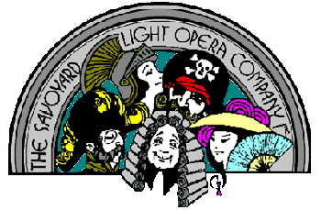

Savoyard Light Opera Company
presents The Mikado, featuring artists from this year's concert!

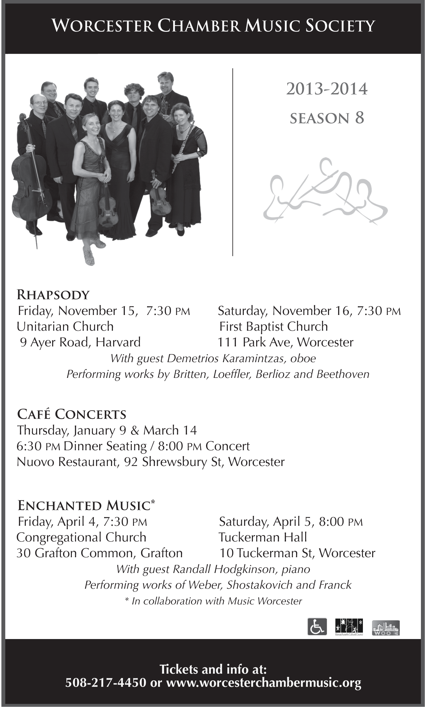

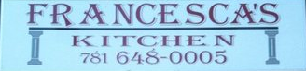
162 Massachusetts Ave
Arlington, MA

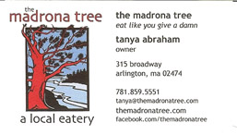





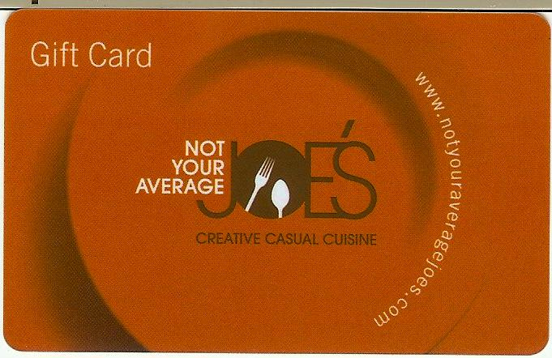
645 Mass Avenue
Arlington, MA

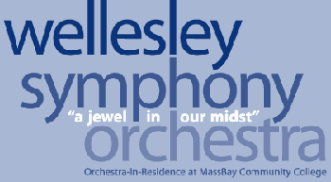



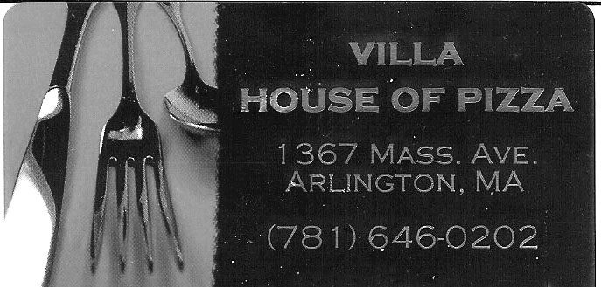

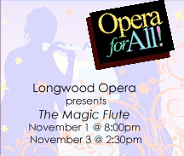



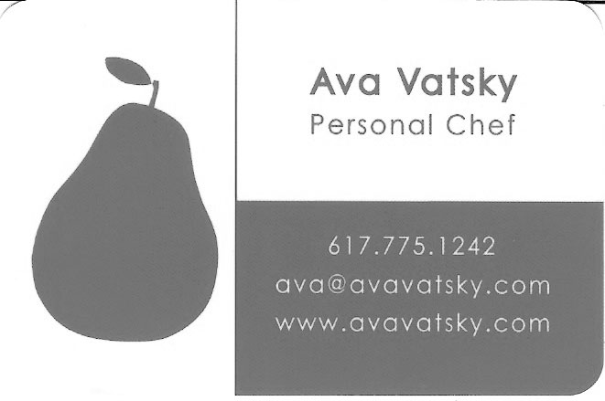

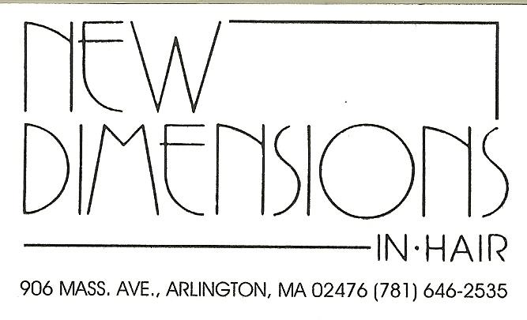





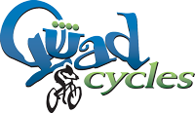
1043 Mass Avenue
Arlington, MA



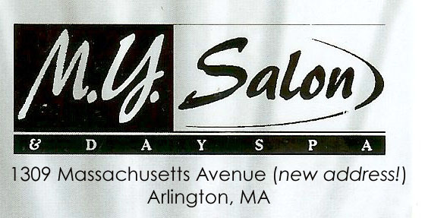

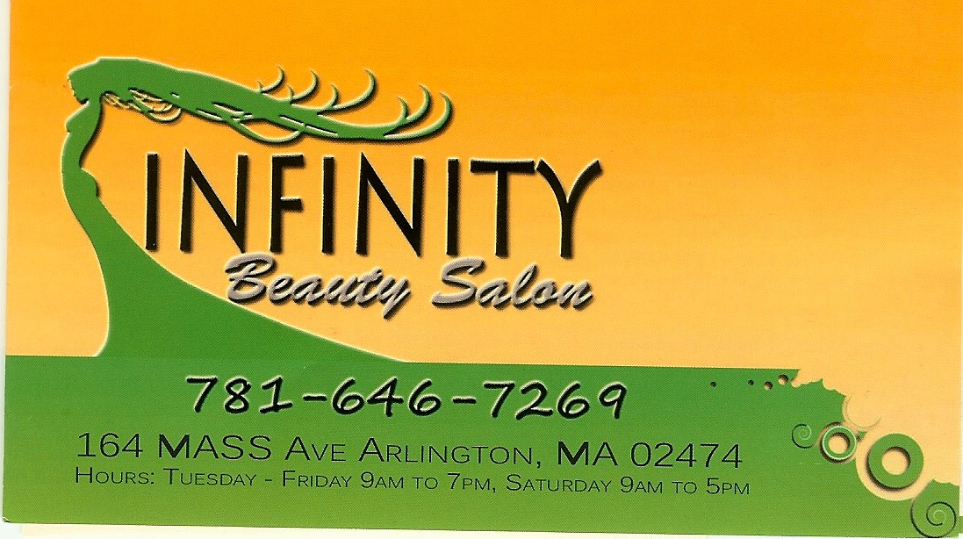





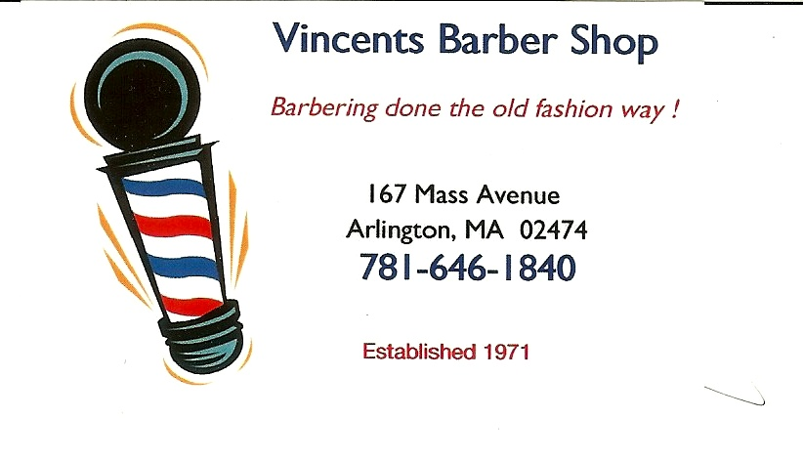
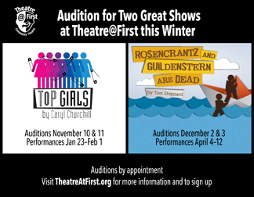



NotloB Parlour Concerts
Fall 2013 Concert Series
See https://sites.google.com/site/notlobmusic/

Today's artists

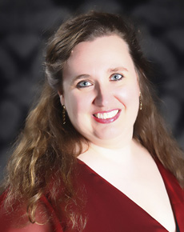  Karen Amlaw,  soprano | 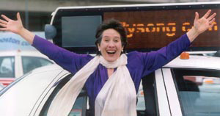  Elizabeth Anker,  contralto
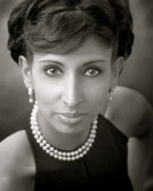  Sangeetha Vandeyar Appavoo,  soprano |  | 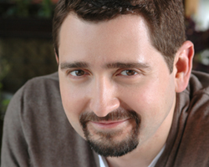  Ethan Butler,  tenor | 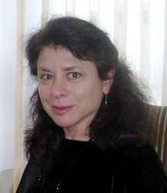  Marion Leeds Carroll, soprano,  concert organizer
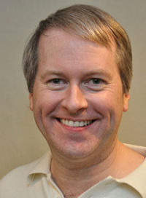  Tom Frates,  baritone |  | 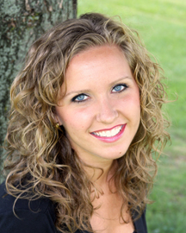  Lauren Hansen,  soprano | 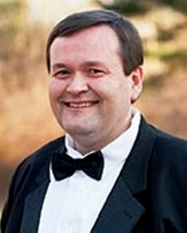  James Hay,  accompanist
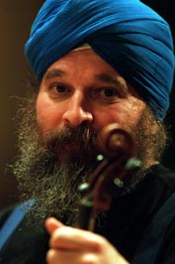  Jagan-Nath Khalsa,  violin |  | 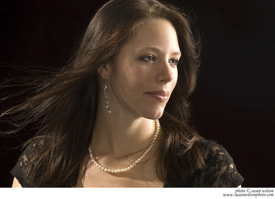  Alyssa Koogler,  soprano | 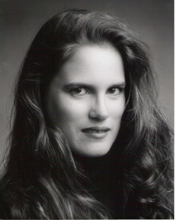  Julie Poole Martini,  soprano
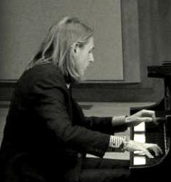  Mark McNeill,  accompanist |  | 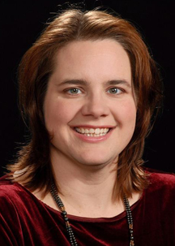  Kate Meifert,  mezzo-soprano | 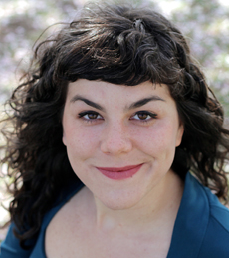  Sophie Michaux,  mezzo-soprano
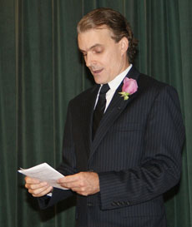  Lyman Opie,  Master of Ceremonies |  | 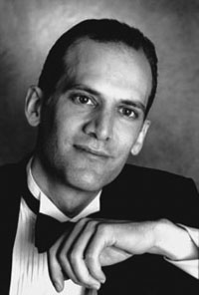  Miles Rind,  bass-baritone | 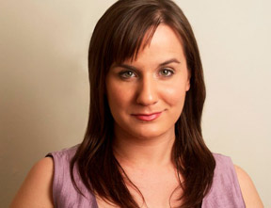  Kimberly States,  soprano
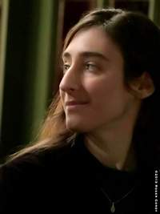  Sonya Taaffe,  soprano |  | 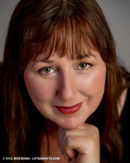  Janine Waneé,  mezzo-soprano | 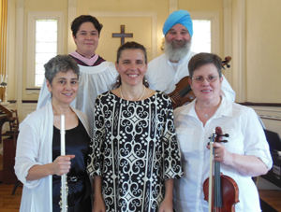  Seele Musicale  Madeline Browning, flute  Jagan Nath Khalsa, violin  Kristjon Imperio, piano

Arlingtonswiftyprint.com

